Assignment Report
Course: AI-Assisted Coding

- Student Name: Shiva
- Roll Number / ID: 2403A51298
- Batch: 24BTCAICSB12

Date of Submission: 23rd August 2025

Table of Contents
- Task 1 – Bank Account Class
- Task 2 – For Loop to Sum Even Numbers
- Task 3 – Age Group Classification
- Task 4 – While Loop to Reverse Digits
- Task 5 – Employee → Manager Inheritance
- Conclusion

Task 1: Auto-Complete a Python Class for Bank Account
Task Description:
Create a BankAccount class with attributes account_holder and balance. Add methods to deposit, withdraw, and display the balance.
🔹 Python Code
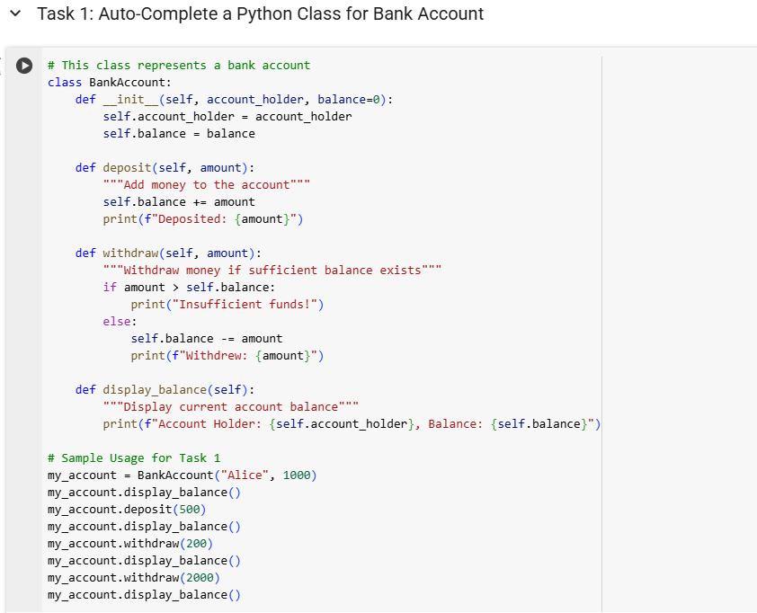
🔹Output

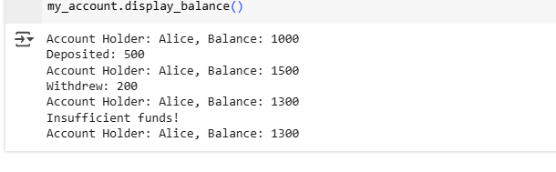

Task 2: Auto-Complete a For Loop to Sum Even Numbers in a List
Task Description:
Iterate a list, check if the number is even, and calculate total of even numbers.
🔹 Python Code
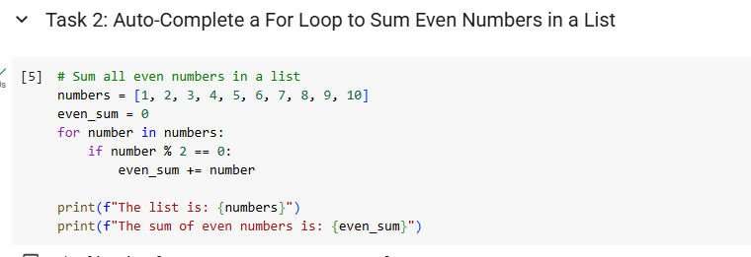🔹 Explanation
- Loops over the list.
- Checks num % 2 == 0.
- Adds even numbers to the accumulator.
🔹 Output

Task 3: Auto-Complete Conditional Logic to Check Age Group
Task Description:
Design a function to classify age into categories.
🔹 Python Code
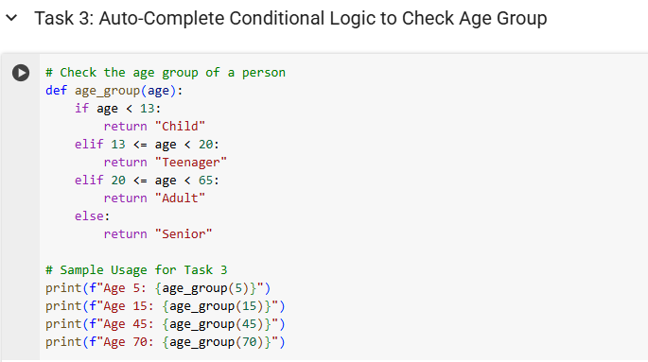🔹 Explanation
- if-elif-else structure handles classification.
- Ranges: <13, <20, <60, else Senior.
🔹 Output
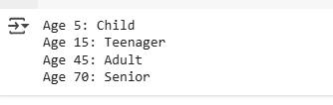
Task 4: Auto-Complete a While Loop to Reverse Digits of a Number
Task Description:
Reverse an integer using while loop.
🔹 Python Code
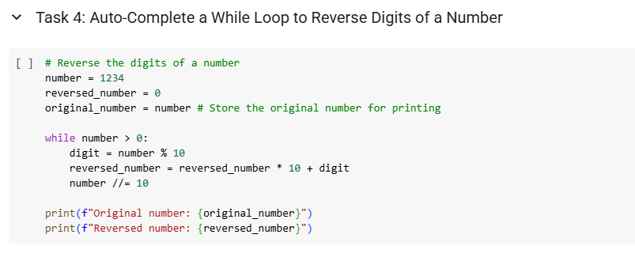🔹 Explanation
- % 10 extracts last digit.
- Builds reversed number iteratively.
- Number shrinks using // 10.
🔹 Output

Task 5: Auto-Complete Class with Inheritance (Employee → Manager)
Task Description:
Implement class inheritance where Manager extends Employee.
🔹 Python Code
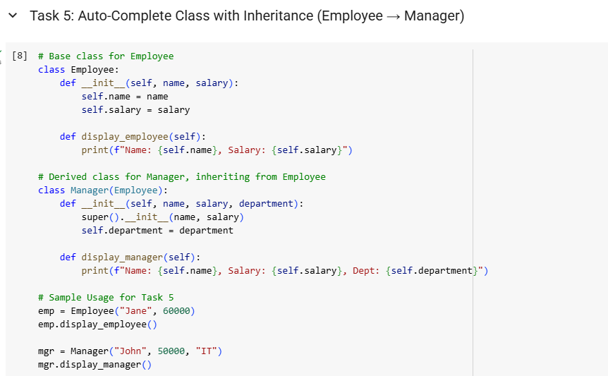🔹 Explanation
- Manager reuses Employee constructor using super().
- Adds department.
- Overrides display() for extended output.
🔹Output
